Dr. Surendra Kumar
Dept. of Economics
M.A. III Sem.
Economic growth and development :characteristics

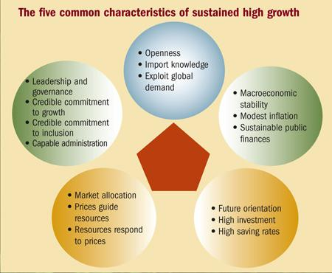

Simon Kuznet (Nobel Prize winner for economics in 1971) identified 6 characteristics of growth. (However the study was based on the experiences of developed nations.) These characteristics were:
(i) High rates of growth per capita output and population.
(ii) High rates of increase in total factor of productivity (TFP) i.e. the output per unit of all inputs.
(iii) High rates of structural transformation of the economy.
(iv) High rates of social, political and ideological transformation.
(v) Propensity to trade
(vi) Limited spread of economic growth.

- High rates of growth per capita output and population.
  - Historically the now developed countries experienced annual growth rates over the past 200 years averaged almost 2% for per capita output and 1% for population. Thus, it would take roughly 36 years for the per capita output to double.
- High rates of increase in total factor of productivity (TFP); the ouput per unit of all inputs.
Historically, technology progress, including the upgrading of existing physical (K) and human resources (H) accounts for most the measured increased in per capita GNP.

- High rates of structural transformation of the economy.
  - Shifts from agriculture to manufacturing and then from manufacturing to services. Note that as the country becomes more economically developed, the contribution of services to GDP also increases.
- High rates of Social, Political, and Ideological Transformation.
  - These include general urbanization process and the adoption of the ideals, attitudes, and institutions of what has come to be known as "modernization."
  - Urbanization is the shift of the population from the countryside into towns.
- Propensity to trade.
Some consider trade as an engine to growth but others hold that economic growth leads to trade. According to Stiglitz and Charlton in Free Trade for ALL, international trade played a major role in the industrialization of North America and Australia in the nineteenth century, and of East Asian economies, India and China at various points in the twentieth century.
- The limited spread of economic growth.
In spite of the enormous increase in world output over the past 200 years, the spread of economic growth is very uneven. A study of the global map shows that most high-income countries are in North America and Western Europe. Other high income countries are Japan, Australia, New Zealand, and some oil producers in the Middle East. In 1998, there were about 1.2 billion people who have less than USD 1 at PPP per day. Furthermore the gap between the richest and poorest 20% of the world's population had widen from 30 to 1 in 1960 to 61 to 1 in 1991. The gap continues to increase.
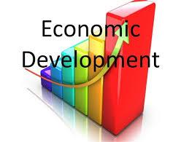
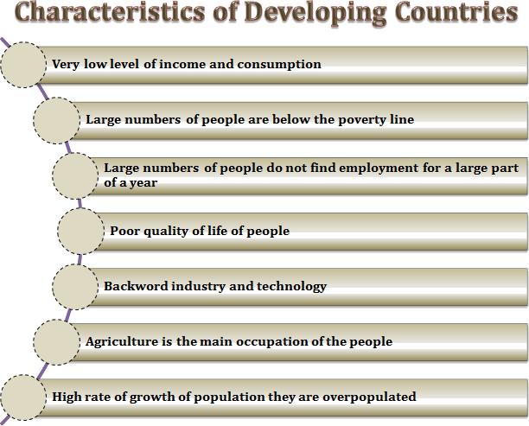
According to Michael Todaro, the common characteristics of developing countries are the following:
- Low standards of living, characterized by low incomes, inequality, poor healthcare, and inadequate education.
- Low levels of productivity (output per person).
- High rates of population growth and dependency burdens.
- High and rising levels of unemployment and underemployment.
- Substantial dependence on agricultural production and primary product exports.
- Prevalence of imperfect markets and limited information.
- Dominance, dependence and vulnerability in international relations.
The main indicators of low standards of living are high poverty levels, low level of incomes, high level of inequality as measured by Gini Coefficient or the Percentage share of poorest quintile in national consumption or income, poor housing, low standard and access to health care, low access to clean water and sanitation, high infant mortality rate, high levels of malnutrition and lack of education.

